Catalyst Center Workshop – Version 2.3.5.x

PnP AP Provisioning

**Americas Headquarters**  
Cisco Systems, Inc.  
170 West Tasman Drive  
San Jose, CA 95134-1706  
USA<http://www.cisco.com>  
Tel: 408 526-4000  
800 553-NETS (6387)  
Fax: 408 527-0883

SITE CREATION 4

Define Authentication Server for catalyst Center 9

Run automation script 10

# 

This sample application was developed in Python and requires Cisco Catalyst Center, Cisco Wireless LAN Controllers. The application's roadmap includes automated Access Point (AP) assignment to site/floor.

The Challenge:

* Mass Access Points deployment
* Ongoing large wireless hardware refresh
* Time required to provision Access Points

The Goal:

* Automate the workflow to onboard APs so that no Network Engineer time is required.

The Solution:

* Use APIs to facilitate Integration between Cisco DNA Center, Wireless LAN Controllers.

The Results:

* Lower cost of wireless deployments
* Increased accuracy and visibility

Business Summary

Simplify the Access Point deployments with an automation tool based on the Cisco DNA Center REST APIs.

# Architecture

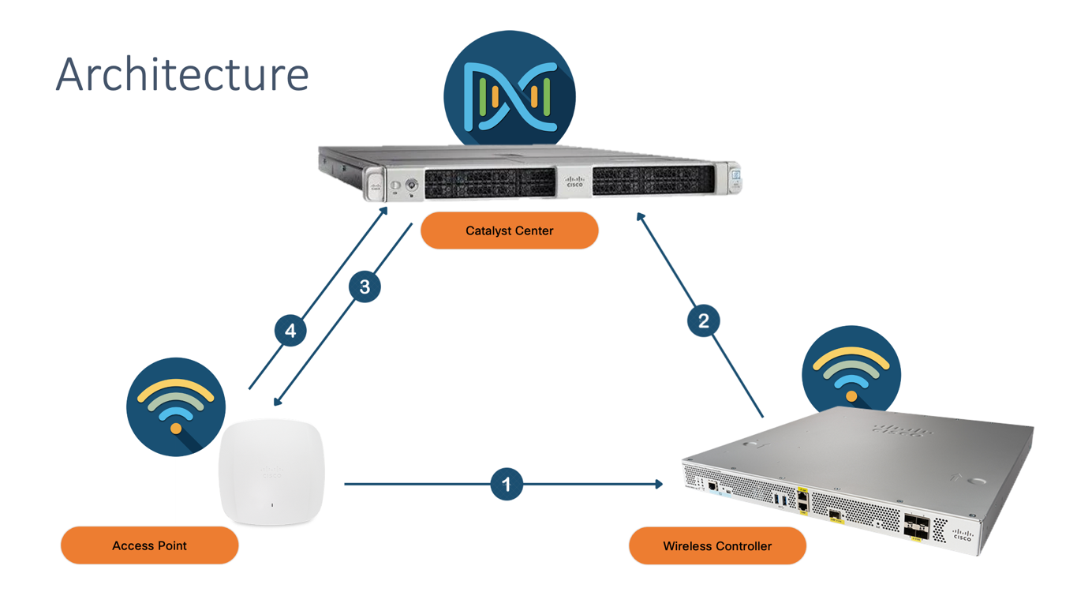

# Workflow

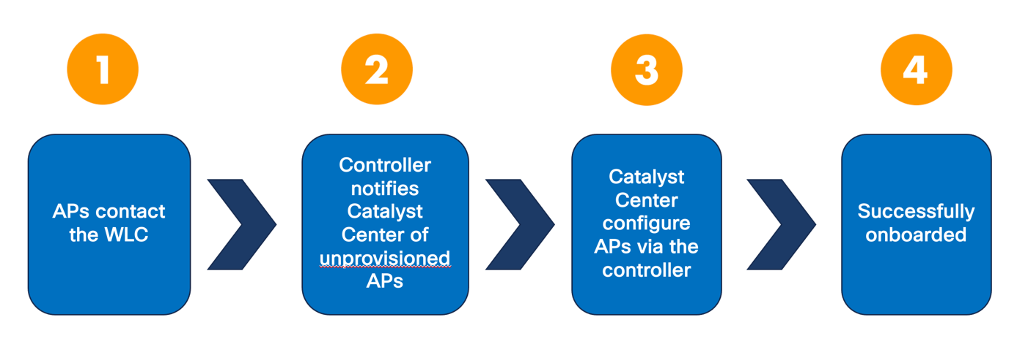

# Site Creation

Connect to Cisco DNA Center UI: <https://192.168.40.9x> (with credentials dnacadmin / Public123$)

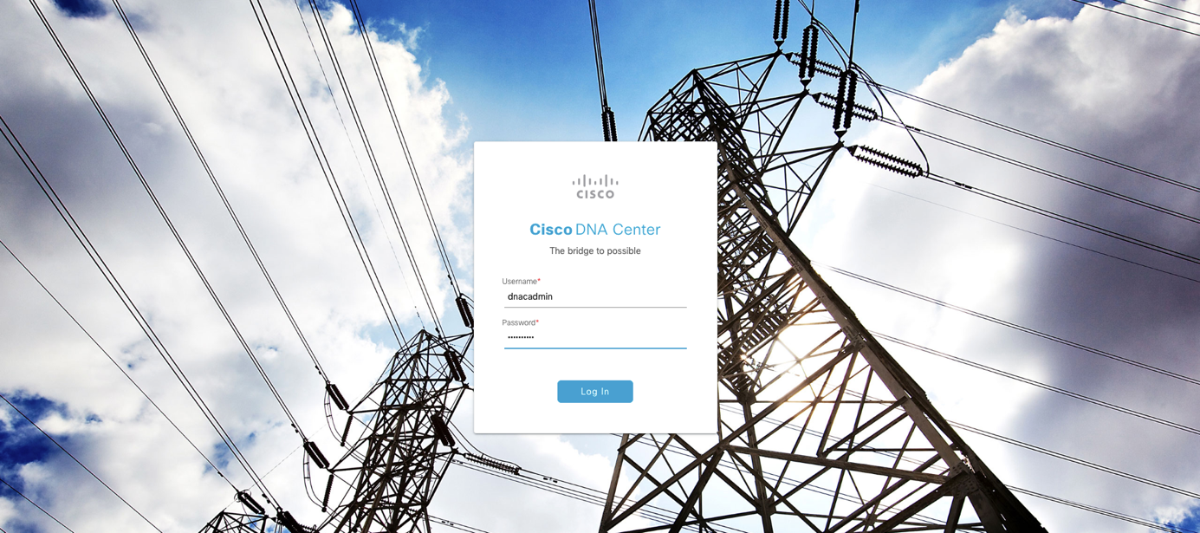

First, you will set up the network hierarchy. It will be composed of 3 levels:

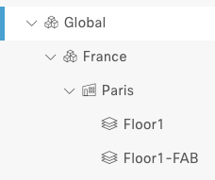

The icons show you the site category: Global and France are sites (region/city or campus), Paris is a Building, Floor1 and Floor1-FAB are floor.

Click on the **Hamburger icon** () then **Design à Network Hierarchy:**

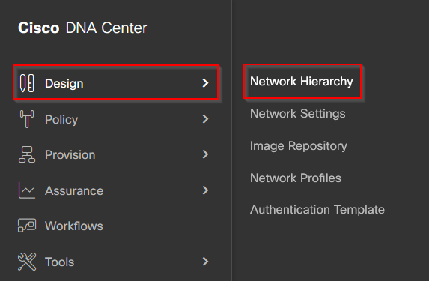

Then click **Add Site à Add Area:**

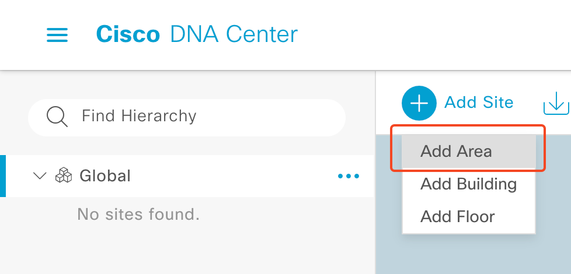

Type the name of your Area (France) and click **Add:**

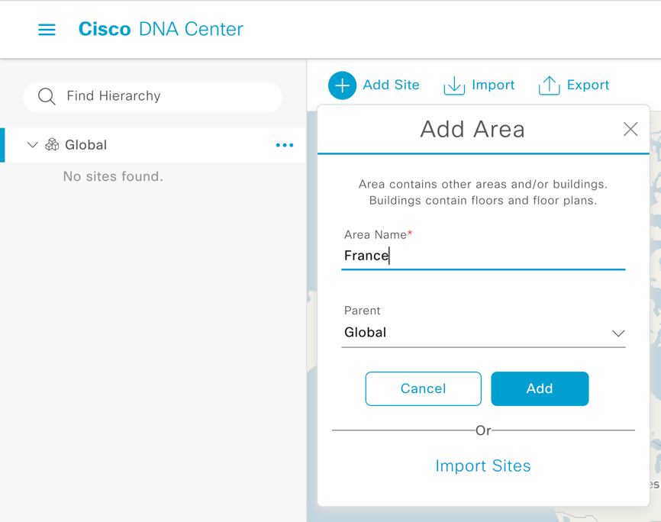

From the **three-dot icon** of your new site (left column) select **Add Building:**

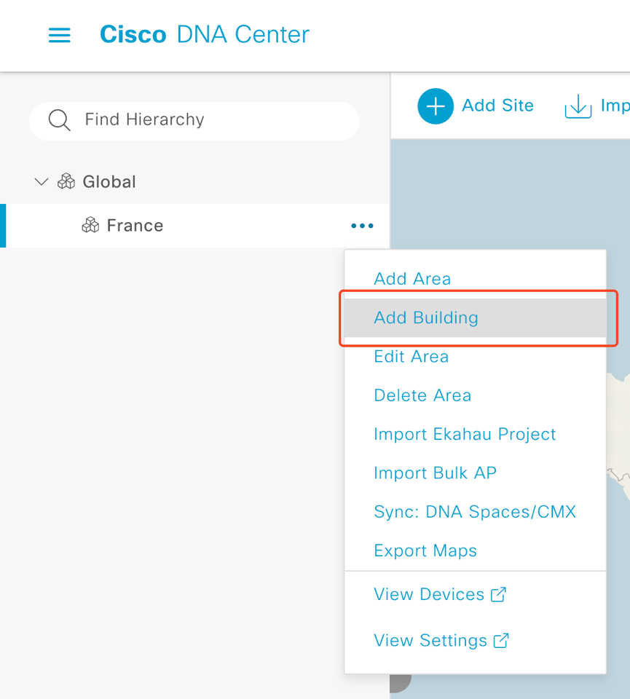

In the **Add Building** box, enter the following information:

* Building Name: Paris
* Address: 20 rue Washington, Paris

Once done, click **Add**:

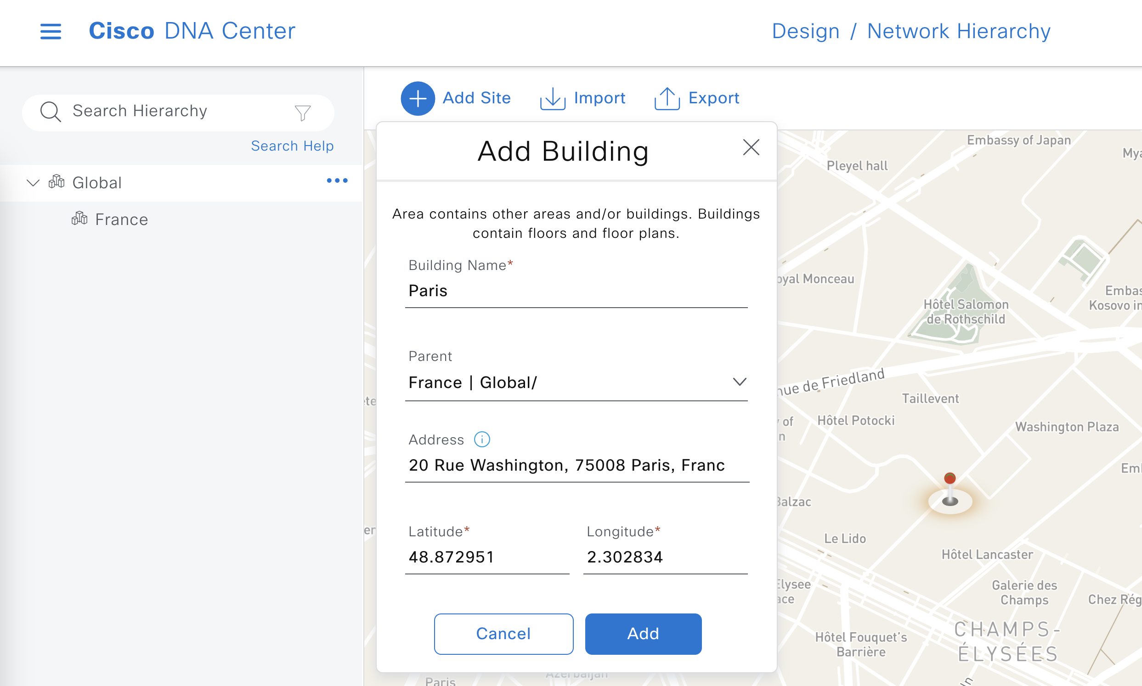

Select now **Add floor**, next to the newly created building:

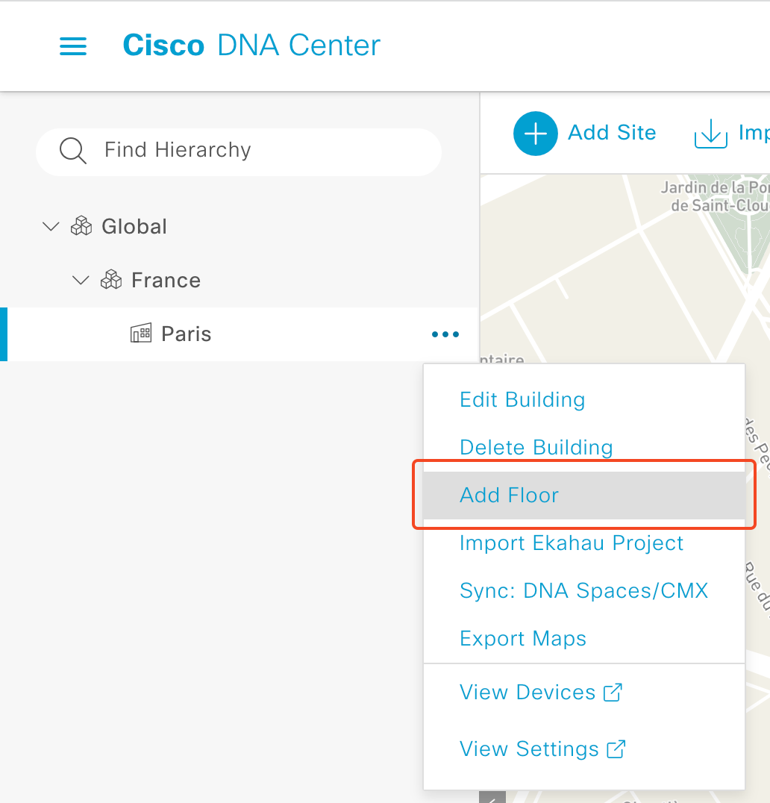

Fill the form as follow:

* Enter the floor name Floor1
* Drag and drop or open/select the image file provided by your lab proctor *floorx-298x164.jpg*
* Select type “Cubes and Walled Offices” (RF Model)
* Change the width to 298 feet
* and end by clicking **Add**

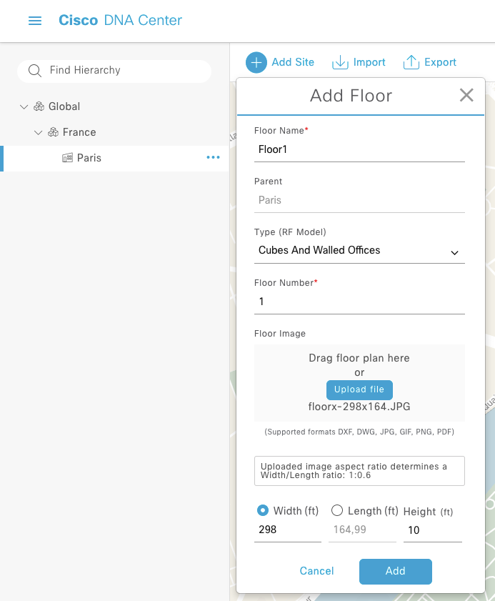

You have successfully created your network hierarchy.

Recup sur github, + lien du git git clone + process + capture du git

# Define Authentication Server for Catalyst Center

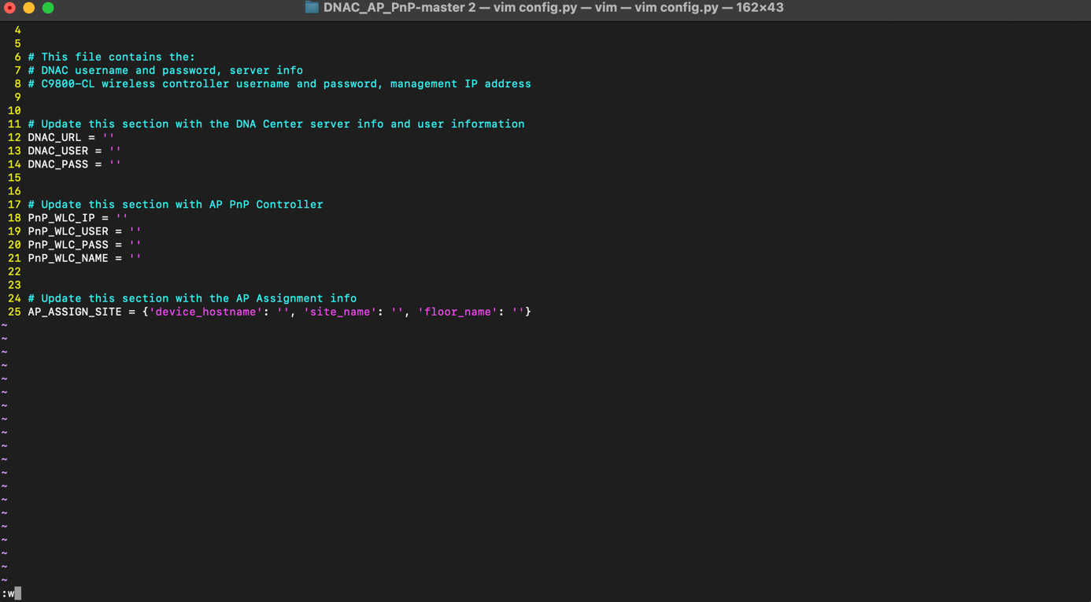

Change the config.py file with the devices, applications, username and passwords that you have in your environment. This file is the only file you need to change.

In the config.py insert information as follow:

* DNAC_URL : https://192.168.40.92
* DNAC_USER : admin
* DNAC_PASS : C1sc$123
* PnP_WLC_IP : 192.168.40.52
* PnP_WLC_USER : admin
* PnP_WLC_PASS : Public123$
* PnP_WLC_NAME : C9800-CL

* AP_ASSIGN_SITE:
  + device_hostname : AP28AC.9E05.001A
  + site_name : Paris
  + floor_name : Floor1

Run Automation Script

Open your terminal and run the file dnac_pnp_ap.py

Check the progress in Catalyst Center interface and in WLC interface.

After ≈ 20 min you’ll see the AP claim in your Catalyst Center

You have successfully claim an AP in your network.